FIRE IN THE EAST

Introduction 3
A prelude to War 3
Invasion of Russia 5
German strategy 5
The Air war in the East. 6
Production - The Replacement Pool 8
Germany 8
Soviet Union 8
Soviet Structure 10
Russian Infantry 10
Rifle divisions and brigades 10
Militia Divisions 11
Airborne troops 11
Russian tanks 13
The Mech Corps
13
Tank Brigades 13
Mech Brigades 14
Russian Artillery 15
Russian Air Force 15
German Structure: 17
German Infantry: 17
Volks Grenadier Divisions: 19
Garrisons / Coast forts: 19
Security Divisions: 20
Mountain Divisions: 21
Jaeger Divisions: 22
SkiJaeger Division: 23
Cavalry Division: 23
Fallschirmjaeger Division: 23
German Panzer Divisions, Motorized Divisions and PanzerGrenadier Divisions: 24
German armored recon: 25
Mot. Divisions and PanzerGrenadiers: 25
German Artillery: 26
German railroad Artillery: 26
Artillery: 26
Nebelwefer: 26
German Air Force 27
German Flak 28
Independent Units: 28
Feldgendarmeri: 28
Pioneers: 28
StuG Battalions: 29
Heavy Tank Battalions: 29
JagdPanzer Battalions: 29
Luftwaffe Field Divisions: 29
Bautrup: 29
German Allies: 30
Finland: 30
Hungary: 30
Italy: 31
Romania: 31
Slovakia: 31
Ostlegion: 31

Introduction

A prelude to War

When Hitler launched the invasion of the Soviet Union sunday 22 June 1941, the Second World War changed. This was a turning point indeed in all aspect of warfare, although it did not show it all at once. History did repeat itself. As Napoleon, who invaded Russia the 23 June 1812, this step proved as fatal for Hitler’s empire as it did Napoleons. Although it took only the Russians until April 1814 to get to Paris, it took the Russians 4 long years to reach Berlin, April 1945. Although Hitler did never capture Moscow as Napoleon did, his armies penetrated twice as far. Even though, he did not succeed in the conquest of this vast empire. The problems were many, as were the errors on both sides. But in the end, the thing that brought Napoleon down was the same thing that ended Hitler’s dreams for the third Reich: Space and harsh environment. Why did Hitler turn to Russia? Well this is not at all easy explained, as it was a combination of things.
Napoleon had to abandon the invasion of England primealy because of Villeneuve`s failure to follow his orders, causing the destruction of the French fleet. Unlike Napoleon, Hitler did not have to abandon the invasion because of Gorings failure to gain air supremacy over southern England. The German air losses over England in the battle of Britain was high, but this had really no strategic value it was more a tactical defeat as the losses here could be replaced. Hitler was still hoping to bring the British to accept their hopeless situation and make them accept a rather, under the circumstances, light peace. As Hitler shows in Mein Kampf he knew that the British resistance would only increase and the willingness to surrender disappear, if he did go to the extreme of invading the British Isles. In fact Hitler’s intelligence service got hold of a memo from the Royal navy to Churchill, that suggested that if the Germans should try to invade England, the Home fleet, based in Scapa Flow, would charge trough the English canal to disrupt the landing forces, with an estimated loss of 85% of the fleet. This shocked him, as he knew that the British would never forgive such a loss. Instead he tried to bend their will by bombing the industrial areas and disrupting their vital convoy service. In the end, the bombing of Britain did infact only boost morale of the Brits, and did little damage, as the bombing of Germany did later in the war. (Strategic warfare was indeed a failure compared to the goals stated by this relative new service.) Hitler did, though, almost bring the British Empire to its knees. As a fully industrialized nation with few raw materials, it was completely depended on imports. In 1942 the losses where so high to the merchant fleet, that a peace was discussed in several corners of England. The initial success of the German submarine force was not followed up as the resources (and Hitler’s attention) drawn by the Russian front, limited the development of new and production of more submarines. But that’s a whole different story.
Hitler was a man driven by economics, fear and prejudice, as were Stalin. The mutual distrust and fear drove each superpower to gradually provoke each other until war was the only option. Although Hitler had a pact with Stalin, he had always seen the vast resources of Russia as a solution to the German oil/resource problem. Besides that, he had passionate anti-Bolshevistic view. The main thing however was the aggressiveness of Stalin. Stalin betrayed the pact as early as June 1940 when he invaded the Baltic states. Hitler had agreed that the Baltic States was Soviet sphere of influence, but not to their occupation. On 26th of June the Soviet 9th army in conjunction with several paradrops, invaded and took Bessarabia and the northern part of Bukovina from Rumania. Although there was no actual fighting, this move brought the Soviet forces unpleasantly close to the Rumanian oil fields of Ploesti, a vital supply source for the German war machine. During the French campaign Hitler was nervous that Russia would intervene. Germany had only 10 Infantry divisions in the East. After the invasion of Bessarabia, and the unwillingness to surrender by Great Britain, Hitler was sure that Great Britain and Russia had an agreement. He then transferred 10 Infantry divisions and 2 Panzer divisions to the eastern front. Not to give an impression of a threat, but as a point, showing that Germany was willing to protect the Balkans and their part of Poland. Stalin however saw this as a sign that he could not trust Hitler. As both Dictators had a deep mistrust for each other, and both where deeply paranoid, war seemed a certainty.
Hitler ordered Paulus (the famous Stalingrad Commander) to look at plans to invade the Soviet Union. Hitler defined the objectives as first to destroy the Russian Armies in the west. Second to advance deep in to Russia to secure Germany from air attacks, this meant a line from Arkangelsk to Stalingrad. The plan was tested in November 1940. The 10th November Molotov (the Soviet foreign minister), landed in Berlin to discuss a range of topics, including the possibly of joining the Axis, but by that time Hitler’s mind was already made up. On the 18 December after receiving Halders report on the invasion of the Soviet Union, Hitler issued directive 21, Case Barbarossa, along with a separate economic plan (Oldenburg), for the exploitation of the conquered areas. A new treaty with The Soviet Union was made on the 10th of January, but this was mealy a smoke screen, and had the sole purpose of deceiving Stalin - and it worked. It was assumed that Stalin would have to fight for the Baltic states and for the Ukraine for supply purposes, thereby making it possible to destroy all Soviet armies in the west. However as the war in Greece, which Italy invaded October 1940 was going badly, and the British was moving to deploy troops there, Hitler needed his shoulder free before launching Barbarossa. In a meeting with Antonescu, Hitler asked him to permit moving german troops through Rumania to support the Italians in Greece. Antonescu hesitated, afraid of what Stalin would think. Hitler then promised him the restoration of Bessarabia, Bukovina and the part of Ukraine up to the Dnieper, for Rumanian help in the attack. He then agreed. On March 01 Bulgaria agreed to let German troops into the country. On March 23 Yugoslavia agreed to join the Axis on a non military basis and to let German forces pass through their country. 2 days later general Simovich carried out a military coup backed by the British. As Winston Churchill put it: “ This morning Yugoslavia found it soul”. This set back, enraged Hitler who hastily made plans for invasion. In only 10 days the plan was formed and on the 6th of April it was launched. The results where devastating: Yugoslavia held out a week, the Greeks 3 weeks - and that was with British help. But as so many battles to come, it had an impact on Hitler as well, he now fully believed that there was no stopping his army, this in the end, was the ruin of the German war machine. Another huge effect of this, was the delay of Barbarossa. On the 1st of April it was postponed from mid may to mid June.
On May 25th negotiations had begun with the Finnish Staff.
The Rumanians where told to make the last preparations at June 25th.
The Hungarians where told to guard their borders more strongly on June 16th.
On June 17th all schools in Eastern Germany closed and all merchant ships were told to leave Soviet ports. On the 18th it was believed that the intention to attack could no longer be camouflaged, but by then it would be too late for the Soviets to react. Although the Germans took serious steps to avoid detection, the British found out and actually predicted the exact date (22nd of June) a week before it was actually set by the germans!!!. However Hitler’s bluff had worked, Stalin didn’t believe his partner would betray him this soon. He thought that the british warnings was only a British trick to lure Russia into conflict with Germany.
22nd of June 03.30 the words Dortmund, Dortmund, Dortmund shattered the radio silence, soon to be followed but thousands of guns. The war in the East had begun.

Invasion of Russia

As often put in military terms, only a fool thinks of Strategy and Tactics, a real professional thinks of logistics and mechanics. Never in the history of warfare has this been more true than in Russia during WWII.
Russia was a vast nation with only a small number of paved roads, and an environment that have proved the doom of every invading army. This time was no exception. To move around in Russia and to preform complex encirclements the Germans needed tracked vehicles. Although the German armored forces consisted of 21 Panzer Divisions they only fielded a bit over 300 tracked vehicles each. Of the 17.000 men in a Panzer Division only 2600 where tank men. Most of their Infantry Divisions where still on foot and most of their artillery where horse drawn. By stripping the Panzer divisions of their 3rd regiment they neglected the very thing that have proved so important in the other campaigns: Cross country mobility. This didn’t mean much in the other campaigns, like the French, where good paved roads were in abundance, but in Russia, it had major importance. Most of the successes in the early stages of the war - by encircling vast numbers of Russian forces - where actually only half successes, as the Germans, due to lack of mobility were slow to close the gaps. Hundreds of thousands of Soviet troops managed to slip out, and lived to fight another day. As Russians have always been masters of improvisation these troops where hastily gathered in reforming armies that, again, had to be encircled. This meant loss of valuable summer time for the invaders and in the end proved fatal to the Germans, as they paid the price of being 20 years behind the theory they themselves had adopted as the key to their success.
The Russians too paid a heavy price for lack of mobility. As the real inventors of blitzkrieg, they neglected the very thing the founder (Thucachevsky, purged by Stalin) of this concept had stated: Mobility. The Soviet forces where in an acute lack of motorized vehicles, meaning that their losses became enormous. The Mech. Corps proved to be too cumbersome, and lacking in trucks, trained men, and radios. They where virtually all destroyed, mainly because they couldn’t move together, tanks without infantry, infantry without artillery and so forth.

German strategy

2 versions were discussed. The first, the orthodox version, were that the Russian armies should be encircled and then destroyed; this was in fact the old Clausenwits/ Moltke idea, which was later developed by Schlieffen. The other version was bolder: Guderians idea was to drive as fast and as deep with the Panzer Divisions as they could leaving the Infantry to mob up. With total air superiority the Panzers could be resupplied from the air. Hitler decided on the first. Would the other strategy have succeeded where the first one failed?? We will never know.

The Air war in the East.

The air war and ground war in the east had several similarities. When the air war began on the 22nd June 1941, it started with a surprise attack by the Germans on all know Soviet airbases. The Soviet Union’s air force was at the time, the largest in the world, with about 8000 planes, however most where obsolete. Only 400 of the new Yak-1 fighters were produced at the time of the attack. Virtually the whole air force in the west where destroyed in the first week of the war. This left the Luftwaffe in total control of the skies over western Russia. Command installations and troop concentrations where hit at will. The effect of this had a devastating on the Red Army. Without at least air parity, it was impossible to coordinate movements and attacks. Using the roads became very dangerous. As several unit histories show, some where virtually destroyed on the roads by the Luftwaffe. Especially the Cavalry Divisions where heavily decimated. Its not easy to dig in your horses. It did not help that the standing order where for the Red Army to immediately begin with a counterattack.
As 1941 progressed, the German army got further into the vastness of Russia. As with the Army this had an effect on the Luftwaffe as it became more dispersed. This opened up for sporadic hit and run attacks by the Red Air force. However the Red air force was so heavily decimated by the surprise attack that the Luftwaffe never lost total control over the airspace. To cope with the heavy losses, the Soviet Air force cut down on training time for pilots and started reproducing old fighter types (I-16). This only added to the very unfavorable odds. Experienced and veteran pilots in modern aircrafts, against untrained pilots in obsolete aircrafts.
The Soviet winter offensive in 1941/42 where a partial success. As with the land war, the Russians where more accustomed to the winter conditions. As most Luftwaffe planes where grounded because of the weather at the primitive frontline bases, their Soviet counterparts where not, often having heated hangars to operate from. Of cause the weather where a problem for the Russians as well, like it was on the ground. But still, no where near the problems the Germans had. Another factor in the success was the newly arrival of 1000 planes from the Central Asia and Far East Military districts. In the mean time Lend lease aircrafts where beginning to arrive in numbers. The Russians did Para drop several units during this offensive. They used the old, but reliable TB-3. But quite a few of these big, slow airplanes where caught buy the Luftwaffe and shot down. It was not until 1943 the Russians got the capability to drop large units again.

When the weather cleared, the Luftwaffe again took full control over the skies. In the new version of the Bf-109, the Gustav, and the new Fw-190 fighters they blew the still quite inexperienced Russians out of the skies. However as Case Blau was unfolding, it did draw the Germans deep into the Caucasus. The immense distances was simply too much for the Luftwaffe to cover. Especially Kleists army group A, was successfully attacked by large numbers of Soviet Fighter-bombers, who unopposed bombed the forward German troops in the Caucasus. At the battle of Stalingrad, the Soviet air force proved an important factor. However this was not as decisive for the air war as the ground battle was.

The decision not to breakout of Stalingrad can be explained in several ways. And it did make some sense. Of cause seen in retrospective it was a foolish decision, but in the winter of 1941 it was the right thing to follow Hitler’s orders to hold on to every inch of ground. This proved deadly to the Soviet flanks, and provided an excellent spring board for case Blau. Another crucial factor was the Luftwaffe success in keeping the Demyansk pocket in supply. Goring promised he could do the same at Stalingrad. As Hitler at the same time refused to believe his intelligence services reports, about the ever increasing soviet forces, the decision makes sense. It would have been the perfect trap for the Russians. As history proved, it was the other way around. Much of this success was due to the promises of Goring. As the Germans where pushed further away from Stalingrad it became nearly impossible to supply it from the air. It was at the max limits of the fighters and the transports suffered heavily.

By the time of the Kursk battle, the Luftwaffe where beginning to get pressed. The ever increasing pressure of the Allies where now showing. A lot of the fighter formations where kept in defense of the Reich. The Soviet aircraft production was now at good pace, and the lend lease equipment where flowing at an ever increasing speed. New models of bombers and fighters proved excellent, for instance the Tu-2 attack plane and the La-5FN fighter. However for the battle of Kursk, Luftwaffe managed to prove superior again, but not decisive as before. The losses were heavy on both sides, but it was the Russians that could afford it.

With the loss of clear airsuperiority the slow and cumbersome Ju-87 Stuka now suffered hard trying to support the Wehrmacht. As a solution the Fw-190 was modified into versions that were able to carry a number of different ordinance, and for the rest of the war, these models became the main attack plane, while the Stuka was fased out.

In 1944 the Allies air strength was overwhelming. The air war over Germany where now taking its tool. The Luftwaffe where outnumbered in Italy. To make things worse, the invasion of France drew lots of its strength, who where much needed on the eastern front.
More importantly the Soviets reorganized it air force. There was now an abundance of good modern aircrafts like the La-7 and the Yak-3, that even led the Luftwaffe to issue a directive for its pilots to avoid fights with these at lower altitudes, and more importantly, well trained pilots. The winter offensive of 1944 saw the help of the Americans who bombed German rail lines all over Germany, and in Rumania. This helped the Red Army to its incredibly fast advance.

1945 saw a total depletion of the Luftwaffe. Even the newly arrived Me-262 couldn’t change the fortunes. The Allies, from their forward bases, flew cap over most German airfields. Although they couldn’t catch the Me-262 when it was in the sky, they could when it was talking off or landing. An even more pressing problem was the fuel. With the loss of Ploesti, and the artificial fuel plants in ruin from allied bombing, there was no fuel to train new pilots. Remarkably the production of figthers was still sufficient as all production of bombers had been changed to fighter-production in 1944. The Soviet air force was now at its height. Each Red Army Front had several air divisions attached, as well at a potent reserve, to use where ever necessary. The new version of the Il-2 Sturmovik proved and excellent close support aircraft. With thousands of these aircrafts Zhukov, launched the final attack over the Oder river and into Berlin.

Production - The Replacement Pool

How on earth did the Soviet Union manage to produce more that the Germans? The Germans, with all its captured resources and industry, where vastly superior the than the Soviet Union on all areas except oil and manpower, by the end of 1941. But it was uncoordinated and ineffective. Corruption and bureaucracy took a heavy bite of the cake. What mattered perhaps even more was the Nazi ideals. Women shouldn’t work, they should stay home and be the core of the family. It was not until 1944, when Albert Speer changed the production of the Reich that things were simplified. German production saw new heights under his clever guidance, even though, at this point the Reich had fewer resources then ever before.

In FitE most equipment is now pooled. This is of cause to make the game more playable. As the war unfolded the units often had new equipment every 6 months. This would mean that 24 slots for equipment simply wouldn’t be enough, and some units would have too much, as old, already assigned equipment can’t be erased.

Germany

During the cause of the war, much captured equipment went into service with the Germans. This must have been a logistic nightmare. They are converted into standard German equipment, in FitE. Overall the German production numbers in FitE is 2/3 of what they historical produced. The Other 1/3 is assumed for the west front. A few exceptions are: most 41 raised units, including the OKH pool of artillery is assigned for the east front. Slightly more German armor goes to the east. Only 1/2 of the twin engine fighters are in the east. The rest are held back to defend the Reich. As mentioned before, the German production increased in 1944, but at this time the Western allies took a much bigger potion of the equipment, so there will be no gear up in FitE. If you think the numbers for some equipment is low, e.g. the Panther tank, keep in mind that most units start full, and there are options that affect these numbers. (German panzer brigades option). The Infantry types of equipment is based on the total men lost. Here all affected nationalities are included, e.g., Finnish, Slovak, Danes, Dutch and many more.

Soviet Union

Regular armies in FitE are on internal support, meaning they cooperate poorly with other armies, especially on the offensive. Once you plan on larger offensives you should therefore consider using the Shock armies, tank brigades from tank corps or other units with dark red background to support the regular units. To help you keeping control of this you should know that ALL UNITS WITH DARK RED BACKGROUND ARE ON FREE SUPPORT, units with tan background (regular armies, early mech corps ect.) are on internal support.
Much of the Soviet equipment is now pooled. Its important to know, that if the Soviet player holds his ground at the historic lines, he will have historic production. Our formula takes into account dates of every city that is marked on the map. This includes cities that did not fall until 1942 e.g. Sevastopol. In TOAW there are some bugs explained under aircrafts.
The Soviet tank units will be able to receive many different types of equipment throughout the war. If all these were present at the same time, the units would obviously be much more powerful than historical, but production of the early models will eventually stop and stock run out, so their equipment will somewhat reflect history.
Lend lease numbers are from the Soviet database. This means, it reflects the equipment that actually arrived, and not what was lost underway. In TOAW the Sherman is a really cool tank, too cool actually. It wasn’t called the Tommy cooker for nothing. So the Soviet player will only receive the early version. At some point along the way the Soviet player have a option to finish his fleet. The soviet actually had a huge fleet half built when the Germans attacked. If he chooses this option he will fall 5% in replacement but gain a few naval units (good ones) and raise in supply due to more safe sea lanes for lend lease.

Soviet Structure

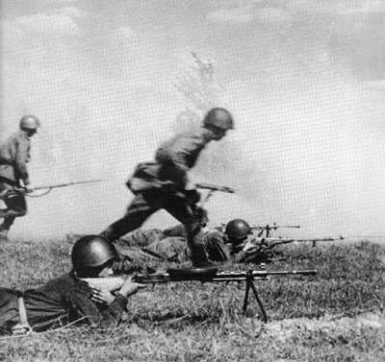

Russian Infantry

Rifle divisions and brigades
The Russians actually mobilized too many men in 1941. It sounds sick but is a fact. The Russians mobilized 1.1 million men a month in 41. That does not include the 5 million that entered the militia and other "volunteer" units. The Russians were hard pressed in 41, they needed men to the front and the rifle divs took too long to train, besides there wasn't really any good leadership at that time, that could handle a rifle div, so Brigades was the answer. They made 159 Rifle Brigades. The rifle brigades will not reconstruct in this game. They where no match compared to the rifle divs. Actually the brigades are viewed as one of the worst mistakes in the Red Army in the WWII. They were indeed slaughtered. They didn't have the staying power of a rifle div, and the men where hastily trained. Most where disbanded or enlarged to rifle divs later on, but in ‘41 there were really no choice. It was to use what you had, and the Russians did. There is mention of student brigades, this was merely brigades made from training schools, not different brigade or structures. The Brigades enter when they were formed.

In Game Notes:
- The Soviet Guards Rifle Divisions are in the game as extra units, except the 101st, 102nd, 103rd, 104th, 105th, 106th, 107th, 114th, 118th and 122nd. The reason for this is the number of units in the game already and the fact that these Divisions where formed in December 1944-June 1945.
- The Brigades of the Shock Armies have been made Ski Brigades. This is not all historical as ski battalions were attached to the Rifle Div. The Rifle Divs was to make ski battalions for individual use, and only a few true ski brigades of 4-5 battalions were made.

Militia Divisions
Well this is a sore point in the game, there were an immense amount of militia units that where mobilized when the war came to Russia. Most of the men in these units were sent into regular army units within weeks of forming. That's why I have only the ones that actually saw some combat listed. All militia divisions where at some point renamed or disbanded in to the Red Army. They WILL reconstruct in this game, but are withdrawn from the game during spring ’42.
They may seem like powerful units at first glance, but their low proficiency makes them vulnerable and easy to route.
Some of the units have gone into the garrison units.

Airborne troops
The Red Army was the first to try airborne operations, and the first to design entire combat units to be delivered by air. The idea was created by Mikhail Frunze in the late 1920's. In 1929 his work was formalized by regulation 29. (Polevoi Ustavlenie 29 or just PU-29) The idea was to hit and destroy enemy targets deep behind the lines. One of the reasons for this was that the bomber force didn't have the capacity (enough bomb load) to do enough damage. By dropping in paratroopers, they could take control or blow up what the bomber couldn't. The first drop was made in 1929 at Gram central Asia. 15 men where dropped by 3 aircrafts to help against anti communist rebels. In the mean time the commander in the Leningrad sector perfected the method. This was no other than M.N Tukhachevsky, the father of modern warfare, and one of the first to get purged by Stalin in 1937. As trails progressed, parachute training became a popular civilian activity. The Communist government emphasized teaching skill that where useful to the Red Army. This promoted even further training, and in 1935 there was over 2000 schools training with gliders and parachutes. In 1935 the Kiev maneuvers dropped 500 men in just 3 minutes. And in 1936, in the Moscow maneuvers the Russians managed to drop 5700 men in just 10 minutes. During these maneuvers the organization of the Airborne Brigades changed to include tanks, artillery and light motor vehicles. In June 1940 the 201st, 204th, and 214th Airborne Brigades took part in 12th Army occupation of Bessarabia, they dropped in front of 12th Army to seize objectives. Although the Rumanians didn't resist, they dropped under combat conditions. By the end of 1940 the Soviet Union had over 18.000 trained paratroopers, most with combat experience. Germany had less than 10.000 in Student's 7th FJD. The rest of the world had nothing larger than a regiment. When the war came to Russia the airborne troops where wasted on defense, and were smashed by German armor and infantry. All though the Russian airborne troops where certainly some of the best troops in the world their light armaments were no match for the regular German units. But as Russia was now full of experienced parachutists (around 100.000), there was no shortage of men. The Airborne forces doubled in size in 1941. But the men wasn't the real problem, the planes were. The Russian airforce had been nearly wiped out in 1941, so many of these men had to fight in regular Rifle divs on the ground. Some action was made though. In the winter of 41-42 elements of 3 corps where dropped in the Moscow-Kalinin area. During the whole war, the Russians rarely dropped more that brigade sized units. Most remembered are the Kanev operation in September 1943, the objective was to drop at division across the Dnepr river, the drop was uncoordinated, and a complete disaster. 60% killed or missing. The Russians did however have some success in dropping small company sized units, to help train partisans and cause havoc among the German rear lines of communication.

In game notes:
- The Russian start with airborne units that reconstruct. Note that reconstructed units loose the ability to perform paradrop. The new Corps that where founded in 1941- 1942 where all converted to Guards before being used as Airborne troops and will not appear in this game. This is the 6th-10th Airborne Corps
- The Russians get 8 (Not the 11th, 12th, 13th, 14th, 15th and 16th, as they where disbanded while forming) Airborne Guards Divisions, but will never get the air transport capacity to use them as such, they are essentially the same as a Guard Rifle Division.
- As most of the Airborne Brigades and Guard Airborne Brigades where used to form either Guards Rifle Divisions or Guards Airborne Divisions, only a few Guards Airborne Brigades will deploy. These are the 1st, 3rd, 4th, 5th and the 8th.
- The Russian player will have sufficient air transport assets for one Brigade from December 1941. In 1942 2 Brigades and in 43 3 Brigades.
- The Airborne Guards Brigades and Divisions have free support and can cooperate with other formations.

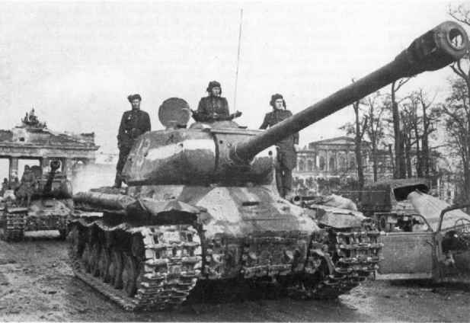

Russian tanks

The Mech Corps
At the start it’s really a huge formation. But it really never worked as most disbanded or eliminated at the end of 41. This includes the really huge divisions in the corps. It was simply to large a formation to really make worth the equipment that was put in to them. All in all some 15000 tanks faced the Germans in the west on the 22. June. They nearly got them all. A few mech corps actually had some experience and good leadership as can be seen in the OOB. The experience of the mech corps is lower than every other Russian unit (except militia) and they are on internal support, meaning they don’t cooperate well with other formations, especially on the offense. They don’t reconstruct, but all their equipment can later be reused in various rifle divs and tank brigades. What survives the first turns make for good blockers at key locations, but shouldn’t be wasted simply to slow down the German advance.

Tank Brigades
As there are no regiments and no battalions in this game, the brigades are really all the armor the Russians get. Many of the brigades mentioned in this OOB were actually destroyed rather quickly, but as its all about saving units, I have chosen the brigade for the staying Russian armored formation. The Brigades go trough the 3 orgs that were for them, ending up with a much more powerful organization than in real life. This is because, point one, to save units, point two, giving then a real punch for the end game. This means that as there is no tank corps. The separate units under a tank corps has been put out in the brigades. The brigades have also been added the late war SU regiments for extra power. This is simply because there is not enough unit room in the game. All in all the Russian tank brigades in ‘44 will have the final org, with a SU regiment, art support and assault infantry, making it the Russian equivalent of the German panzers (still a bit smaller though) with roughly 150 tanks.

Mech Brigades
A mech Corps usually had 3-4 Mech brigades and a tank brigade attached. Now here is the real crème de la crème in the Russian OOB. This is the best and most flexible units. Good for everything and very mobile. One could say that this is really the final product of war. So how come the Russians didn't make all their armor units like this??

In game notes:
- All Russian tank/mech formations are on free support, EXCEPT the starting Mech Corps.
- No tank/self propelled tank regiments of any kind appear. Instead the Regiments are incorporated into the tank/Mech Brigades, giving them a bigger punch.
- Normal Tank Corps are included except the 27th Tank Corps, which never completed forming. And the 29th who had brigades from existing Tank Corps (The 8th) Instead the one Brigade from the 29th that wasn't from another Corps have been exchanged with the double from 31st Tank Corps (32nd Tank Brigade for the 100th Tank Brigade).
- As Soviet tank/mech formations where formed from each other all the time I have done some creative thinking. There is NO normal Mech Corps, and there is NO free Brigades of any king (Except SU-Brigades). Instead, the Soviets get all Guard Tank Corps and all Guard Mech Corps. That is in addition to the normal Tank corps. This is to prevent the Soviet player from packing a too powerful punch earlier on, and giving him a real monster late in the game. (Guards arrive later that the normal formations, but are much, much better)
- The early tank brigades in the game start with a very low number of tanks assigned. This allows for their primary equipment being rifle squads, so the units still will be able to reconstruct even if the stock of the T-34/Early runs out later in the game. On the plus side this makes the units “lighter” so they don’t take up so much rail-capacity, but they need a few turns on map before they are truly “combat-ready”.
- As the Soviet player gets all the Tank brigades, that are both Guards and the normal brigades, the Normal brigades that are under a Front HQ will NOT appear in the game. This adds up what is lost and what is gained. This however means that the Soviet player has less tank brigades early, but better ones, and more later. Or explained better, the 36 Tank Brigades in the Guards, will be removed from the Soviet Tank Brigades in reserve at the Front HQ. Its loosing 18 brigades early on, and gaining 36 later, this is also to compensate for the loss of Tank regiments, although every tank brigade gets a H tank Brigade attached later on.
- The SU regiments are used among the Rifle Divs and the Mech/tank/ Units. This is to save units. Allthough only 10% of all Rifle Divs got a SU-reg attached historically, they often had a independent one attached when attacking. So it all makes sense.
- However, The Guards Mech Corps will get a SU-Brigade each, e.g. 9. This is completely unhistoriclay, but helps display the growing power and coorperation of the Red Army. There were formed 14 SU-Brigades historically, these units are NOT ingame. The Soviet will just have to do without ;)
- Most of the Soviet Cavalry Divisions are NOT reconstructing. The Soviet Cav Guards Divs are. A few divs are not in the game, that’s because they were either too small to be represented or they where disbanded before seeing combat. The Guard Cav divisions are added to the Mech Corps to add more flexibility. They were historically as they are here, only the size of large brigades. As there will be no Guard cav Corps HQ, the assigned troops ( SU and more) are added to the divs, making them a nice mobile task force.

Russian Artillery

In Game notes:
- Soviet artillery is located partly in each army HQ and sometimes the army also include a separate artillery unit. These units suffer from the internal support of the army and is mostly useful on the defense.
- The artillery under the Fronts are on Free support, making them more useful and finally the artillery divisions will arrive in their own formation, also on free support. These units are really powerful
- The Mortar Brigades are separated from the Art Divisions, making them a more mobile force. They are added under the Division they where in.

Russian Air Force

In General, because of the TOAW system is lame, insane and really stupid and most certainly not made for long campaigns, the air forces on both sides have to be unhistorical to some point. This pains me a lot, but there is no way around it. Two major points (flaws) comes to mind:

1. The first piece of equipment in a unit decides whether it can reconstruct or not. You need 66% of available, first listed, equipment. E.g. a Soviet fighter formation with 106 I-16, in 1944 will not reconstruct if there is not enough I-16 in the replacement pool. As production of I-16 stops in 1942, there is not likely to be that number on hand. This happens even if there is enough of all the other aircraft in that formation e.g. yak-3.

2. When a air formation flies a combat mission it uses the longest range of the aircrafts assigned. This means that if 106 I-16 with a range of 17, is in the same formation as 0 (Zero) yak-1 with a range of 23, the I-16 will fly 23 hexes. What happens then, is that because the I-16 exceeds it range its strength is reduced to 1%. This means that for practical reasons, a drunk, armless, blind person in an old zeppelin, with a frozen water pistol, can shot them all down. And he will.

This, of cause, among other problems, could be solved if there was enough events and no counter limit.

In Game notes:
We have tried to make the best out of these limitations and even employing their consequences to our desired result:
- The Soviet Air force now starts WITH types combined in division units (bomber, fighter, attack). These divisions is actually quite close to history in terms of types and numbers, so it’s not because of some sick sense of humor we have put fighters in the bomber divisions, and the attack divisions have up to 5 or 6 different types of planes. This of course WILL make them perform very badly, in accordance to point #2 above, but then again the VVS had a hard time in the early war.
- Now #1 comes into play, as these obsolete types, which are the primary equipment in the divisions, eventually will run out. This means that the unit eventually won’t be able to reconstruct anymore as the game progress.
- Instead new units arrive in a steady stream. Units organized more appropriate, with just one type for each unit. The units are a combination of 3 regiments, put together not because they were historically, but because at one point the used the same type of plane. Now of course most of the regiments changed the type of plane they used during the war, but to take that into account would use up unit and event space not present.
- The Long Range Bombers fall a bit out of this category. They start on the map and will remain throughout the game.
- All Yak-9 and Yak-3 models have been put together under the designation Yak-9, simply because the Yak-3 have (wrongly) been given inferior stats in TOAW.

German Structure:

The Artillery Regiments are under the Headquarter, while most small units e.g. Panzer Jaegers equipment is distributed among the rest of the units in the Division. This is an effort to keep the number of German units under 2000, to enable them to split up units. Also it eases game play.
German overall proficiency is 80. They will reconstruct at 70
German general supply distribution is 80
All German units start as veteran.

German Infantry:

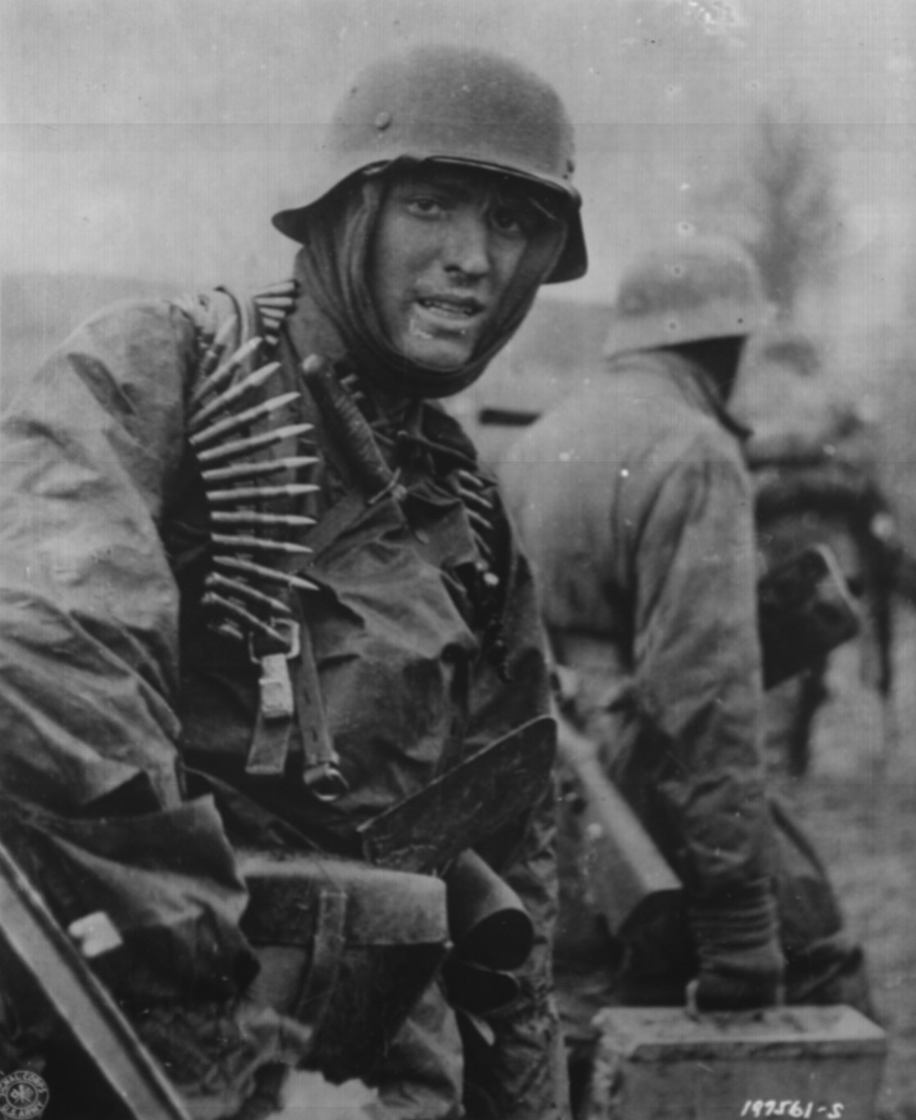

In WWII a total of 389 German Infantry Divisions where active. Needless to say, Companared with the total of 57 Panzer, Panzer Grenadiers and SS Divisions, most of the fighting and dying was done in the Infantry. In 1941, when Barbarossa began, the
German Infantry Divisions included the following: (Fighting subunits only)
3 Infantry Regiments, each with 3 Battalions (each with 3 Companies of 180 men)
1 Artillery Regiment
1 Reconnaissance Battalion
1 Panzer Jaeger Battalion
1 Pioneer Battalion

In Fire in the East, a German Infantry Division consists of a Headquarter, with the Artillery Regiment, and 3 Infantry Regiments. In the Infantry Regiments, the reconnaissance, Panzer, Jaeger and pioneer Battalions equipment are added. This was done to ease game play and because of the limits of the TOAW engine.

Because of the superior tactics, planning and overall leadership, the German squads are heavy Infantry squads, in addition to a small number of assault squads

In 1942 the war in the east had drawn a huge chunk out of the German Infantry Regiments, and there were no replacements to refit them to full strength. As a consequence of this, it was necessary to cut the Companies size to 80 men, compared to the former 180. This however did not mean a proportionate loss of combat efficiency, primarily because it was much easier to command an 80 men Company than a 180. Besides this, the number of Battalions where reduced from 9 to 7. Later in the war, the Infantry Divisions were reduced from 3 to 2 Regiments. This is why the German Infantry Regiments start over strength. In fact, after 1941, almost none had its full Component of men and equipment, at any given time. The German Infantry Divisions in 1942, were only half the size as a similar US/British Division. Later in the war, the difference became much greater. This was one of Hitler’s greatest blunders. Instead of replacing the depleted Divisions, he insisted on mobilizing new ones, thereby reducing the number of actual fighting men.

Improvements to German Infantry Divisions in Fire in the East:
- Most of the initial anti tank capabilities of the Infantry Divisions, becomes obsolete. In 1942 the German PAK 40/41 is added. The 75mm AT gun replaces the historical PAK 40/41 (Panzer Abweer Kanone); which in TOAW is underrated, as it doesn’t reflect the special types of German AT munitions.
- Tank Destroyers, Hetzers are applied as well. As the Soviet tank forces grew, it became clear, that the Infantry were ill equipped to deal with the increase in Soviet armor. Often an Infantry Division had a Company or even a Battalion of Tank Destroyers attached.
- Sturmgeschutz: like the above. When the Soviets tactics and firepower grew in strength, it became necessary to upgrade the defense and attack capabilities of the German Infantry Divisions. Although only around 50% got a Sturmgeschutz Battalion, I found it prudent to add it to all, as the Germans most certainly would have done, if they had the numbers to do so. It’s noteworthy to mention, that the Germans also used their Sturmgeschutz as tanks, and not like their Soviet counterparts, who used their Assult guns (SU/JSU) only as an Infantry support role.
- Assault squad AT+: This is to reflect the arrival of the Panzerfaust/Panzerschreck. These very efficient Infantry AT weapons, were widely used, and took a heavy toll on the Soviet Armor. (Who sometimes put mattresses on their tanks to counter them) These weapons where the forerunners of the modern Infantry AT weapons. The Germans developed special anti tank tactics, and where to a large degree capable of fighting off the masses of Allied tanks.

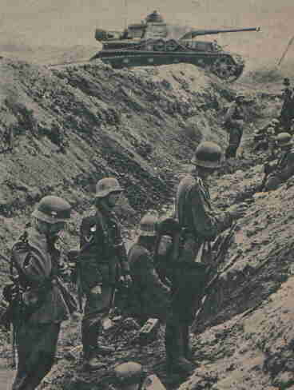

Volks Grenadier Divisions:

As all Volks Grenadier Divisions where actually reconstructed Infantry Divisions, there are none of these Divisions in Fire in the East. The Divisions were named Volk (peoples) Grenadier Divisions to boost morale and to encourage the German people. They were in fact, a bit weaker than normal German Infantry Divisions in Artillery, as there where shortage of 105mm Howitzers at the time.

Garrisons / Coast forts:

German garrisons in Fire in the East, are a mix of units that were either static, fortress or training Divisions. Also, a large part of the German forces were used to garrison vital ports.
They will not reconstruct in Fire in the East.

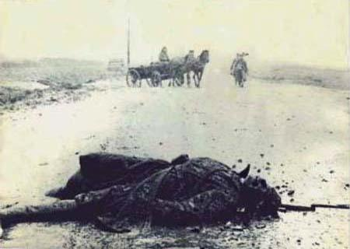

Security Divisions:

When the war in Russia began, it was deemed necessary for each army group, to have some sort of rear security, to protect the supply lines and lines of communication from partisan groups and bypassed Soviet forces. As the war progressed, the need for rear area protection grew, as partisan harassment increased. The Security Divisions did not need a large portion of heavy weapons to deal with partisans, but needed enough to out gun any enemy. This need changed when the huge Soviet breakthroughs where achieved. Much too often these Divisions were thrown in to the shattered line, or used to fill the ranks of depleted Divisions. They often used whatever equipment they could get their hands on, including Soviet volunteers.

Usually a Division contained quite a few different sub units, which again were rotated among them. In Fire in the East, their standard organization is made with normal rifle squads, and low in heavy weapons. Otherwise they are organized like an Infantry Division. None of the Security Divisions will reconstruct.

Improvements to Security Divisions in Fire in the East:
- 75mm AT guns: As more and more of these Divisions saw frontline action, it became clear that they had to have at least some form of anti armor component.

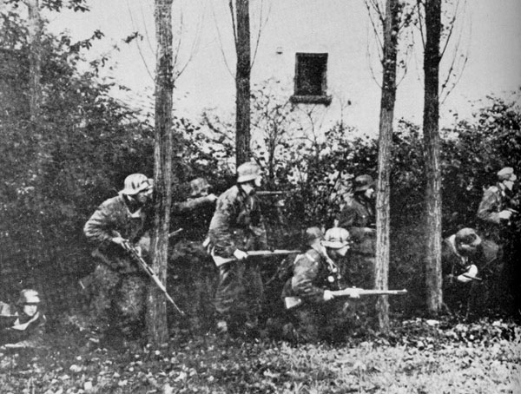

Mountain Divisions:

The Gebirgs Jaeger Divisions where originally used in mountains, but much too often they found themselves fighting in the open. They where supposed to have light equipment, thereby enable them to function in rough terrain. There where 2 different structures, one for real mountain use and one for open or semi open use.

In Fire in the East there is no distinction between the two types, the organization for the open one is chosen, although this makes them almost like a Infantry Division. They can with some right claim to be the ones that got the furthest into Russia as they planted their flag on the top of Mount Elbrus in the Caucasus. There is still some debate about this, since some recon elements reached Astrakhan.

Gebirgs Jaeger organization (fighting sub units only):
- 2 Gebirgs Jaeger Regiments (3 Battalions each)
- Artillery Regiment
- PanzerJaeger Battalion
- Pioneer Battalion
- Mountain Feldsatz Battalion

As with the Infantry Divisions, the Artillery Regiments are included in the Division Headquarter and the Recon, Panzerjaeger, Feldsatz and Pioneer Battalions are distributed among the 2 Gebirgs Jaeger Regiments. This also means that the 2 Gebirgs Jaeger Regiments, Companared to the 3 Infantry Regiments, have a larger Component of the subunits equipment. All Gebirgs Jaeger Divisions will reconstruct.

Improvements to the Gebirgs Jaeger Divisions: (for more info see under Infantry Divisions)
- StuG-IIIg: a Company each
- 75mm AT: (In larger numbers than the Infantry Divisions as Gebirgs Jaeger Divisions only have 2 Regiments, to distribute them amongst)
- Assault squads AT+

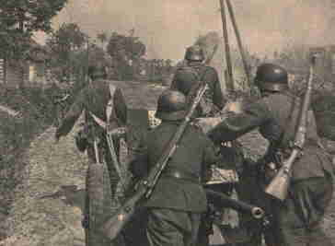

Jaeger Divisions:

The first Jaeger (Hunter) where formed in December 1940 as part of the 12th mobilization wave. The Jaegers were to be used in low mountainous or remote areas, where there was no use for fully equipped GebirgsJaegers. The Divisions were supposed to be light and maneuverable.

A normal Jaeger Division consisted of (fighting subunits only):
- 2 Jaeger Infantry Regiments
- Artillery Regiment
- Reconnaissance Battalion
- PanzerJaeger Battalion
- Pioneer Battalion.

Jaeger Divisions in Fire in the East:
As with the Infantry Divisions, the Artillery Regiment are included in the Division Headquarter, and the Recon, Panzerjaeger and Pioneer Battalions are distributed among the 2 Jaeger Regiments. This also means that the 2 Jaeger Regiments, Compared to the 3 Infantry Regiments, have a larger Component of the subunits equipment. However, as the Jaeger Divisions are supposed to be light, they do not include heavy rifle squads, but normal rifle squads and only 100 of them. All Jaeger Divisions will reconstruct.

Improvements to the Jaeger Divisions:
- Assault guns ( StuG-IIIg). In World War II a number of Jaeger Divisions received an assault gun Company/Battery.
- 75mm AT guns. As with nearly all other units, the Panzerjaeger Battalion were upgraded to keep up with the invention of more powerful tanks.

SkiJaeger Division:

Only one SkiJaeger Division where formed, from the 1st SkiJaeger brigade and the 19th Panzer Grenadier brigade. It was formed on June 2nd, 1944. It was a relative heavy unit, with captured Soviet tanks, and self-propelled guns.

It was organized as follows (fighting sub units only)
- 1st and 2nd SkiJaeger Regiments (3 Battalions each and a support AT Company)
- 152nd Artillery Regiment (with 18th Heavy Mortar Battalion)
- 85th Ski Pioneer Battalion
- 1st Ski Fusilier Battalion
- 152nd PanzerJaeger Battalion
- 152nd Heavy Ski Battalion
- Ski Felderzatz Battalion

In Fire in the East, the Artillery Regiment is under the HQ, and the subunits is pooled into two Ski Regiments. The Ski Division start at historical full strength and will not receive any upgrades. The Ski Division will NOT reconstruct.

Cavalry Division:

The only German Cavalry Division in the game is the 1st Kavalarie Division. Created Feb 14th 1940 from the 1st Kavalarie brigade, this unit fought in Russia until November 28th 1941 were it was converted to the 24th Panzer Division. It consisted of:
- Division HQ
- 4 Reiter Regiments
- 1st Reiter Artillery Regiment
- 1st bicycle Battalion
- 40th Panzerjaeger Battalion
- 40th Pioneer Battalion

In Fire in the East the PanzerJaeger and the Bicycle Battalions are added to the other units. The Artillery is under the 1st Kav HQ.

Fallschirmjaeger Division:

Only one paratrooper Division will be available to the Germans. This is the 7th Fallschirmjaeger Division. This is a powerful unit, able to take key points and hold them. Remember the house rules about airdrop. Historically the 7th FallschirmJaeger Division where called the 7th Air Division, for camouflage. It was meant to finish off Case Blue by dropping Batumi.

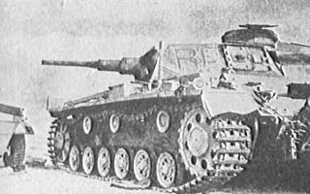

German Panzer Divisions, Motorized Divisions and PanzerGrenadier Divisions:

Probably the most famous units of the German armed forces. Under skillful leadership, these units changed the warfare all over the globe. However the same Panzers that had proven decisive in Poland and France were not the same as the ones that entered the Soviet Union. In the fall of 1940 the organization where changed, following Hitler’s orders to double the numbers of Panzer Divisions. The Panzer Divisions where stripped of their 2nd armored Regiment. This meant that now each Panzer Division only had half the tanks, than it had previously. This meant slower off-road movement and a lighter punch. On June 5th 1942 the Schutzen Regiments, were renamed PanzerGrenadier Regiments, this is their start name in Fire in the East.

In Fire in the East each Panzer Division consists of:
- 1 Headquarter, with the Artillery Regiment
- 1 Armored Regiment
- 2 PanzerGrenadier Regiments
- 1 Kradschutzen Battalion
- 1 Aufklar Battalion
- 1 Panzer Pioneer Battalion

Other fighting sub units included in these are: Army Flak Battalion and Panzerjaeger Battalion. These are added into the other units of the Panzer Division,

As the war progressed, it became clear that they needed some extra firepower, however there were no spare equipment left. Only a handful of Panzer Divisions received additional support units, in the form of StuG Battalions or an additional AT Battalion.
These are added with the historical units in Fire in the East.

The numbers of tanks in Regiments are the correct for the Barbarossa operation. Later the upgrades with Panthers and Tigers are taken from factory papers, witch states witch Panzer Division got these tanks. It’s all historical.

The Kradschutzen Battalions where motorcycle Battalions, used for reconnaissance and sweeping maneuvers and where ideal to quickly capture key spots. In 1943 they where absorbed into the reconnaissance units, they will not reconstruct in the game

German armored recon:

The German Aufklar units have the historical Companonent of equipment. However, the armored cars have been standardized. The start armored car is the Sdkfz 231-8 and the other 2 additions are in 1943 the Sdkfz 233 and in 1944 the Sdkfz 234.
These additions are made, as the Kradschutz where transferred to the reconnaissance arm of the Divisions, and only these 3 are chosen instead of the (more) historical equipment, because of the reinforcement system of TOAW. If we were to add the ability to have the correct numbers of all the various versions they had, they could end up having, if none were lost, more armored cars than the whole German army had historically.

Mot. Divisions and PanzerGrenadiers:

Now here comes the tricky part. There are no Motorized Divisions. They are all called Panzer Grenadiers. Originally they where called Schutzen Regiments, until June 5th 1942. Here they all start as PanzerGrenadiers. This is because there simply aren’t enough events to withdraw and replace them as the game progresses. And it saves unit slots, which is equally important, as the number of units where approaching the limit of 2000 even for the Germans. We wanted to keep the flexibility, of the Germans, so they can break down any units in the game. Furthermore two very unhistorical aspects are to be mentioned in the structure of the PanzerGrenadiers:
1. They have halftracks. Historically the Germans were notoriously short on halftracks. In general only one Battalion where equipped with halftracks.
2. They start with 75mm AT guns. The 75mm AT gun did not appear in numbers before 1942. However in Fire in the East, the PanzerGrenadiers, will have a full component of these guns, making them able to deal somewhat with the large Soviet tank formation. As experienced players know, its not smart to attack tanks with Infantry alone.
These two upgrades make the PanzerGrenadiers much more powerful then they were historical, in addition to this they have the following upgrades in Fire in the East:

Upgrades to the PanzerGrenadier Regiments:
- Sdkfz 251/16 Sp gun. Added as the Infantry guns became more mobile
- Marders for more antitank effect,
- 88mm AT gun, this is a historical and natural upgrade to the Grenadiers antitank capabilities
- Assault squads AT+. For the same reason as the other German units.

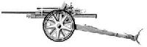

German Artillery:

In general, the German Artillery where shifted around different fronts during WWII. It’s difficult to withdraw units in TOAW, since this would simply drain events. As a consequence most will be on the eastern front, and most will not reconstruct.

German railroad Artillery:

The Germans used a lot of Railroad guns during the 2nd World War. This included thier own and captured ones, mostly French. Some special mention has to be made for formations like the 628th Artillery battery which had 2 600mm Karl mortars. Beasts on tracks, these were highly effective against the fort at Brest-Litovsk. The Karl mortars had a “smaller” brother named Gerat. They where “only” 540mm, and where used during the Warsaw uprising with horrific results. The most popular one was the 800mm Gustav Gun. Designed in 1937, by Krupp, and given to Hitler as a birthday present in 1942. The soldiers using this monster called it Dora, adding to the common belief that there where two. Only one was built. It served with the 672nd Railroad Battery, during the Sevastopol siege. It was later transferred to Leningrad. Another famous railroad gun where the Anzio Annie. It was used against the Anzio bridgeHeadquarter in Italy.
However railroad guns were slow, had a slow rate of fire and used up a large portion of manpower. Given the shortage in men, this was not a good investment for the Germans.
Most Railroad guns have been pooled together to save units in Fire in the East. They will not reconstruct.

Artillery:

Besides the Artillery attached to the Headquarters, the Germans had a pool of independent Artillery. This pool provided Artillery support where ever it was deemed necessary. As explained above, it’s simply not possible to make this work in the TOAW system. Most historical German Artillery will appear as reinforcements in Fire in the East. However most will not reconstruct.

Nebelwefer:

A ruthless piece of equipment. Originally used to lay out smoke, this proved highly efficient against enemy Infantry. The Germans were a bit slow in seeing this, but in the end came up with a highly efficient weapon. It was much more accurate than its Russian counterpart. However, its range limitations was a big drawback. In Fire in the East a historically number of Nebelwerfers units arrive. They will all reconstruct, thereby giving the Germans a bit back for the lost Artillery formations.

German Air Force

Because of reasons explained under Russian Air Force it’s not a good idea to mix plane types with different moves. When introducing new equipment it is therefore necessary to withdraw units and replace them with one equipped with the new plane-type. In order to save event these withdraws are determined by unit colors. The colors have no effect on gameplay as all Luftwaffe formations are on free support, and different color schemes can be found in same formation.
When a unit with a particular color is withdrawn can be found in the image below. The withdrawal occurs at the end of the mud-periods, where no fighting has taken place for 5-6 turns. This is to prevent units from being withdrawn when they are reconstructing and therefore not on-map, since TOAW doesn’t withdraw the unit in that case.
Sometimes the unit is replaced by an identical named unit, but with new equipment, but they could also just be removed from the map, in cases where units moved away from the Eastern Front to either West Front, Africa ect.
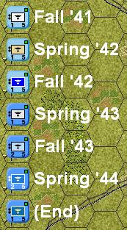
In Game notes:
- 109E/F is the primary fighter in start of game but is replaced during 1942 by either Me109Late (G/K) and/or FW190(Late). 109E/F is after this still used in some of the ground attack squadrons, and by minors.
- FW190(Early) is used as the ground attack version of the 190 (F/G) and appear in the Schlactgeswaders, while the Fw190(Late) is considered the fighter variants (A/D)
- Me110 is eventually withdrawn from game and some of them replaced by Me210/410.
- Ju87 remains throughout the game, although some units is upgraded to the Fw190(early). A few units using Hs129 start to appear in 1942. Like Ju87 some of these stay till the end, others are withdrawn.
- Most Kampfgeschwaders don’t change equipment (Ju88 and He111). Only units using the Do-17 is upgraded before 1942 to Ju88.
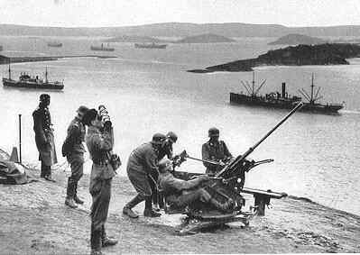

German Flak

Never have so many troops been saved by the Flak as the German Infantry during Barbarossa. The Infantry simply had nothing that could kill KV tanks or for that matter T-34. It became routine to pick up the phone and call the flak people whenever you saw one of these monsters. Most famous were the German 88mm Flak gun. Designed to track fast moving aircraft, it was ideal in knocking out slow moving tanks. And furthermore it could do so at very long range. It had perfect optics and caliber. It was suited as both and anti tank/ anti aircraft role and as an Infantry gun. It was so efficient, that it was later designed as a real AT gun, and where used at a tank gun, mainly on the Elephants ( Ferdinand) , Tiger, Nashorns and Jagdpanthers. Simply the best all-round gun during WWII.

Flak units are either Luftwaffe or army flak. Historically some Flak Divisions were transferred from the Luftwaffe to the army. This is also the case in Fire in the East, and they have the historical numbers of guns. Most Flak units will reconstruct.

Independent Units:

Feldgendarmeri:

Military Police, is historically, they will however, not reconstruct.

Pioneers:

The Independent engineers were a vital part of the German offensive strategy. Most will reconstruct.

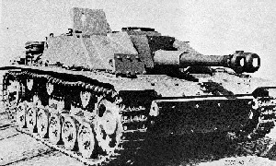

StuG Battalions:

During the war a number of independent StuG Battalions where raised, as independent support units for the Infantry. In Fire in the East they will receive a component of the good Jpz IV.

Heavy Tank Battalions:

One should mention that there will be more heavy German Tank Battalions than historically. This adds only to the flexibility of the Germans as they will not get more tanks than historically produced.

JagdPanzer Battalions:

The historically number of JagdPanzer Battalions will appear, and most with the correct historical equipment. However as these units, like most of the German Artillery, where shifted from front to front the Germans will probably end up with more than they did during WWII. This shouldn’t matter much, as the production stays the same. They will all reconstruct.

Luftwaffe Field Divisions:

During the winter of 1941, the German losses where massive, and the need for troops higher that ever. Goring, always looking for a way to please Der Führer, promised 22 Divisions to Hitler. However these units where poorly led, and under equipped. In 1943 they where eventually absorbed into the regular army. They will not reconstruct.

Bautrup:

These units are for railroad repair. They will all reconstruct.

German Allies:

Finland:
On November 30th 1939 Soviet Union had attacked Finland with a force of approx. 22 rilfe divisions and 6 Tank Brigades. Defending against that Finland had 9 Divisions and a number of smaller units. In all service branches that added up to about 337,000 men. They were well trained but lacked modern equipment, especially in regards to AT-guns, tanks and planes. To compensate for this they used practically all equipment they could get their hands on, both donations from other countries, (whose sympathy all lay with Finland. Only Germany stayed out, because of the German-Soviet pact that had named Finland as Soviet sphere of interest), and large quantities of captured equipment.
Initial soviet defeats at first held the Russian bear off, but with commitment of additional offensive forces, the Soviets managed to crack the lines and a painful peace treaty was signed March 13th 1940, where Finland was forced to surrender large parts of Karelia, the port of Hangö, as well as the area around Salla in central Finland.
The Finns saw Barbarossa as a way to get these areas back and had even before June 22nd 1941 allowed German troops to enter Northern Finland. In the weeks that followed they then started their offensive and during the summer and fall of 1941 they captured their old land areas back, as well as proceeding further in order to get the best possible defensive lines (and as a mean of getting a good peace-negotiating position).
Their armed forces had spent the peace period between the Winter and Continuation War to improve the army and air-force, but they still was in need of more heavy weapons. As war progressed they managed to buy some of this from the Germans. In Summer of 1944 the Soviets launched a major offensive to knock Finland out of the war. The Finnish forces was once again forced back, but once the Soviets started to remove some of their divisions for use in the summer offensive vs. the Germans, the front stabilized and the Finns signed a peace treaty that meant they would give up the land lost in 1940 for good, but would keep them independent.
Finnish units won’t reconstruct and with the loss of Helsinki they will surrender and their units will be withdrawn.

Hungary:
Hungary had lost much of their pre-WWI territory in 1920, so in 1940 they joined the Axis in exchange of the territory lost to Rumania, and their first assignment was the assisting of the German invasion of Yugoslavia in April 1941.
On June 27th 1941 they joined the war on Soviet Union, but their units didn’t prove adequate in the front line compared to the Germans. Instead many of their divisions were being placed in rear areas as security forces, until the extending front lines in summer of 1942 forced the Germans to request the 2nd Hungarian army to guard the Front at the Don River. During the Soviet winter offensive in 1942-43, this entire army was surrounded and destroyed. A big part of this was caused by the lack of suitable AT-equipment in the Hungarian units, that left them with hardly any ability to counter the Soviet armored forces.
The Hungarian units will be able to equip with german AT-guns later, but their low proficiency makes the unreliable. They will not reconstruct and are withdrawn with the loss of Budapest.

Italy:
Much to Mussolini’s anger, Hitler didn’t inform him of Barbarossa beforehand. However he quickly gathered a Italian expeditionary Corps to be sent to Russia. It was later increased to an entire army in 1942 to help guard the front. It was also severely hit in the Soviet winter offensive, lacking proper equipment. Their units won’t reconstruct.

Romania:
In 1940 Romania was forced to concede territory to both Hungary (Northern Transylvania) and the Soviet Union (Bessarabia), but despite the lack of support from either Germany or Italy the country remained Pro-Axis and joined them on November 23rd 1940.
Germany had sent their 11th army to attack out of Romania, along with some air units, but real ground action didn’t start before around July 3rd 1941, where the army assisted by Army Group Antonescu (with 3rd and 4th Rum armies) attacked towards Odessa and lower Ukraine. AG Antonescu was soon disbanded so it’s not present in FitE, and even though some Romanian units were also under direct german korps command they have all been placed in the 3rd and 4th Army. Later units for the 1st Res army also arrives. This isn’t an army that was historically at the eastern front, but it has been included to avoid the large armies that would have appeared if all units was to be in 3rd and 4th armies.
Like the other minors, the Rumanians are equipped partly with obsolete weapons, which was also one of the reasons for their disastrous results in winter ’42-’43. Their lack of firepower is somewhat dealt with as time goes by, but they still haven’t got the punch of the German divisions.
Their units don’t reconstruct and they will be withdrawn by the loss of Bucharest.

Slovakia:
Slovakian forces participated already in the campaign against Poland in 1939, and 4 days after the start of Barbarossa they sent a expeditionary force consisting of 2 divisions to participate in the attack.
Offensive operations was made difficult by the lack of (motorized) equipment, so an ad-hoc unit was formed named the Pilfousek Brigade (after it's commander). This unit combined the motorized units of the two divisions.
The brigade only existed for around a month, before being returned to Slovakia for a refit.
Here it was used to form the 1st Slovak (mobile) Infantry Division or “Fast” Division. Of the remnants was formed the 2nd Security Division.
In FitE only the last two units exist, and neither will reconstruct. Should Bratislava be lost, they will be withdrawn.

Ostlegion:

The Soviet Union is far from a homogenous population and a number of minorities actually saw the Germans as liberators from their oppressors. This allowed the Germans to raise a number of units based on recruits from these areas. Some of these eventually formed whole divisions under the SS, like the Estonian, Latvian, Ukrainian ect. These units' counters have a blue icon on the black SS background color.
Other units were formed in seperate “Legions”, like the Georgians and Armenians.
Neither of these Ost-units reconstruct.

